Hikoi CT4846-05 Current Probe Verification Procedure

Clifford x5326   
10/25/2018

Contents

1. Summary 3

2. DC Accuracy test at Full range 1000A 3

I. Test Equipments 3

II. Test Setup 3

III. Test Result 5

3. AC Bandwidth 5

I. Test Equipments 5

II. Test Setup 6

III. Test Result 6

# Summary

Hikoi CT6848A is a current probe with sensitivity of 2mV/A, range from DC to 1000A, bandwidth upto 20KHz. The current probe is used with 1Mohms scope input impedance. This test report includes the verification procedure and test result for the above specs.

In summary the probe meets the spec and it is a solid design.

# DC Accuracy test at Full range 1000A

## Test Equipments

HP6002 DC Power supply 50V 10A

0.5 ohms 50W sensing resistor

MSOX3104A 1Mohms input

Agilent 34411A Multi Meter

300 loops wire test fixture with 26 gage wire

## Test Setup

The DC Accuracy is measured by the following setup

The 300 loops wire has resistance about 9.5 ohms. It is connected with a 0.5 ohm sensing resistor in series and then connected to HP6002. Adjust the power supply voltage from 0 to 33.3V, which created the DC current from 0A to 3.33A. The total current passing through the clamp is from 0A to 1000A. The accurate current reading is obtained from the voltage readout on the sensing resistor by DMM. The test setup is shown in Figure 1 Test setup for current Probe.

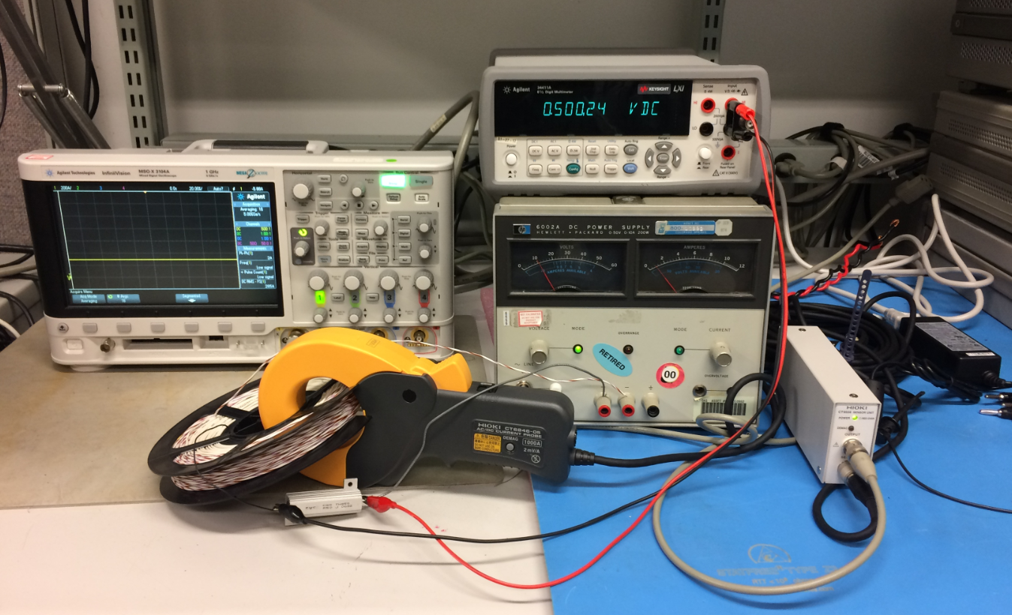

Figure Test setup for current Probe DC accuracy

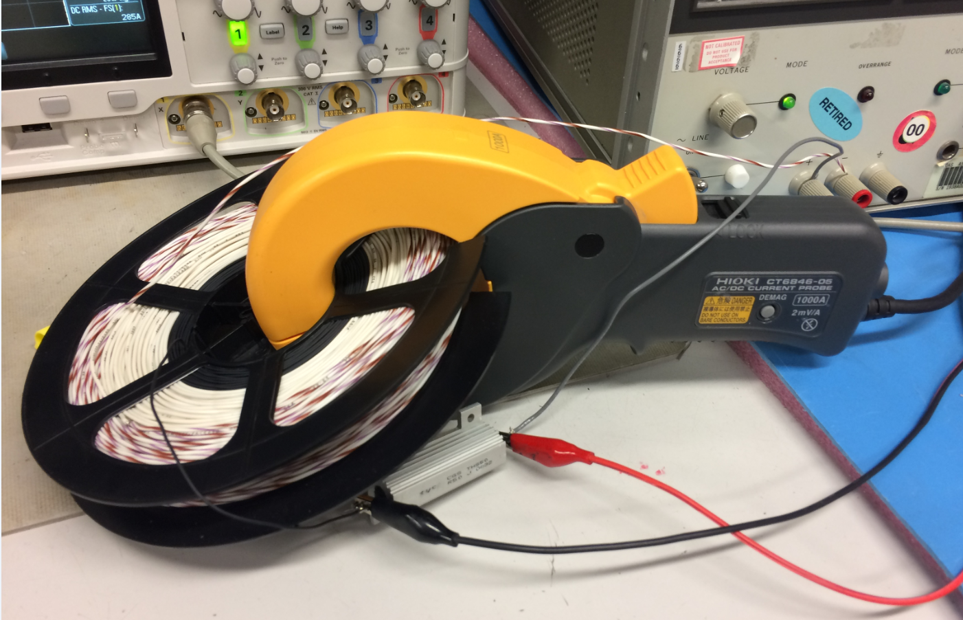

Figure 2 Test setup for current Probe DC accuracy

## Test Result



Figure 2 Test result current Probe DC accuracy

Totally 22 sample points are selected and tested. The average of the error is 0.36% with standard deviation of ±1.5%. The probe output is measured by Agilent MSOX3104A which has DC offset error of 2%. Therefor the measured error is most likely caused by the scope instead of the probe.

# AC Bandwidth

## I. Test Equipments

Function Generator 33600A

0.5 ohms 50W sensing resistor

MSOX3104A 1Mohms input

300 loops wire test fixture with 26 gage wire

## Test Setup

The loop with sensing resistor is connected to the output of the function generator. The frequency is swept from 1Hz to 20Khz, sinusoids waveform with maximum amplitude of 10Vpp The probe output is connected to the MSOX3104A channel one which is set 2mV/A unit, the sensing resistor output voltage is connected to channel two, the scaling factor is 300/0.5=600.

The frequency response is calculated by dB(chan1/chan2). The result is given in the Figure 5.

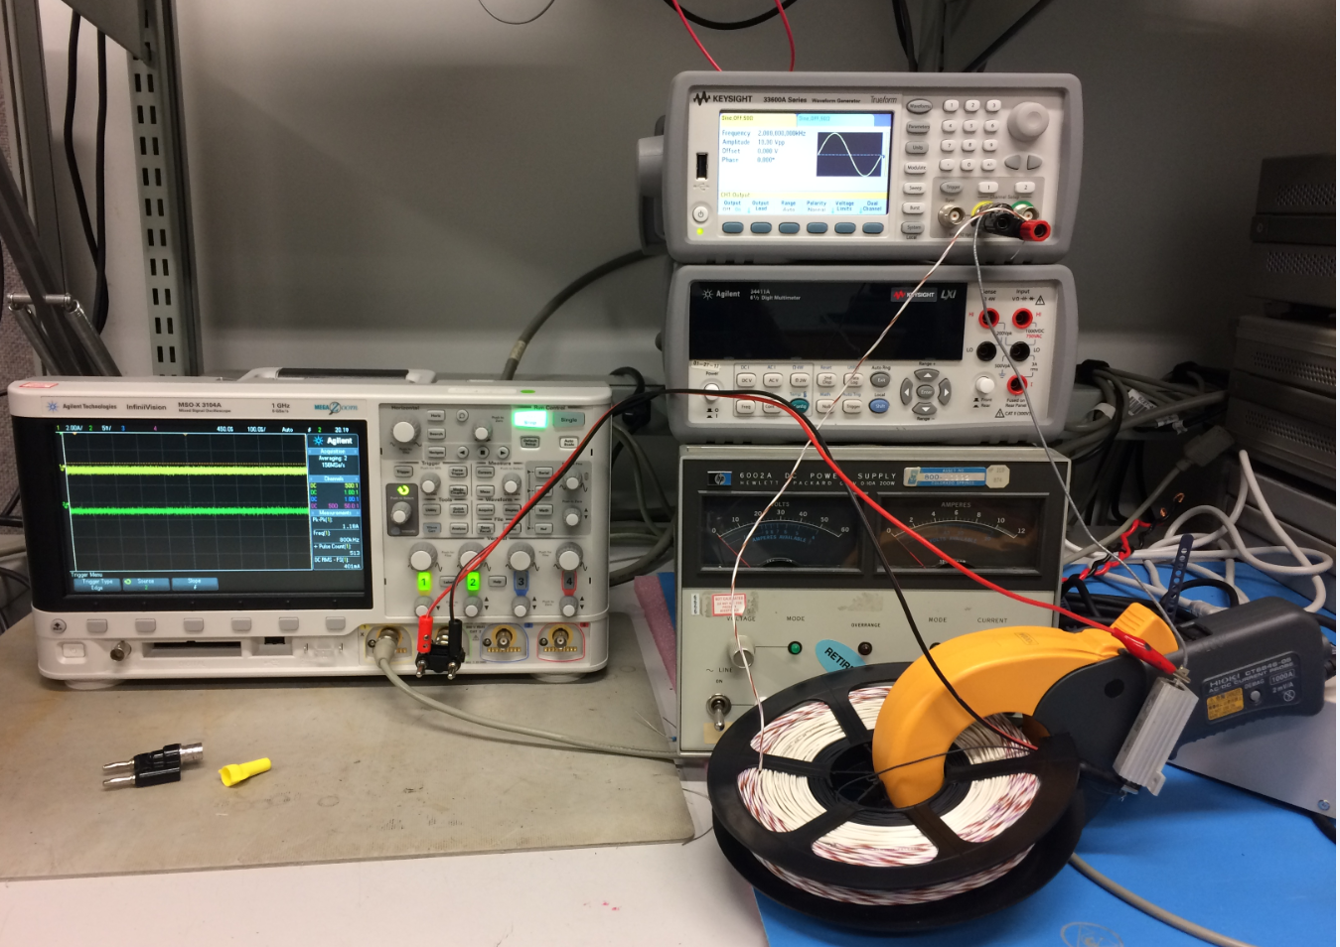

Figure AC bandwidth test setup for >1A case

## Test Result

The output of the probe over frequency is pretty flat all the way to 2Khz and a small resonance is observed from 2Khz to 20KHz. However this may be caused by the scope’s noise floor.

Note: The 300 loop wire has about 12.2mH inductance, at 20Khz the impedance is about Z=10+1533j, Due to the maximum output of the signal gen is capped at 10Vpp, the maximum current given by the signal gen at 20kHz is about 6.5mA. At this level, the output of the probe is about 3.9mVpp, the output of the sensing resistor is around 3.25mVpp. Both are very close to the scope noise floor. Therefore the noise is large and the frequency response at this frequency contain larger noise.



Figure AC bandwidth result